AI-linker V3 White Paper
Version 3.c
Product Abstract:
AI-Linker V3 is not only a GPS tracker, but also an enterprise mobile solution.
AI-linker v3 is a state of the art product stepping on previous version. it overcomes all issues of the previous version and also has many enhancements . It has a solid base and also has enhanced stability. It designs for convenient installation, reliable on road and flexible integration.

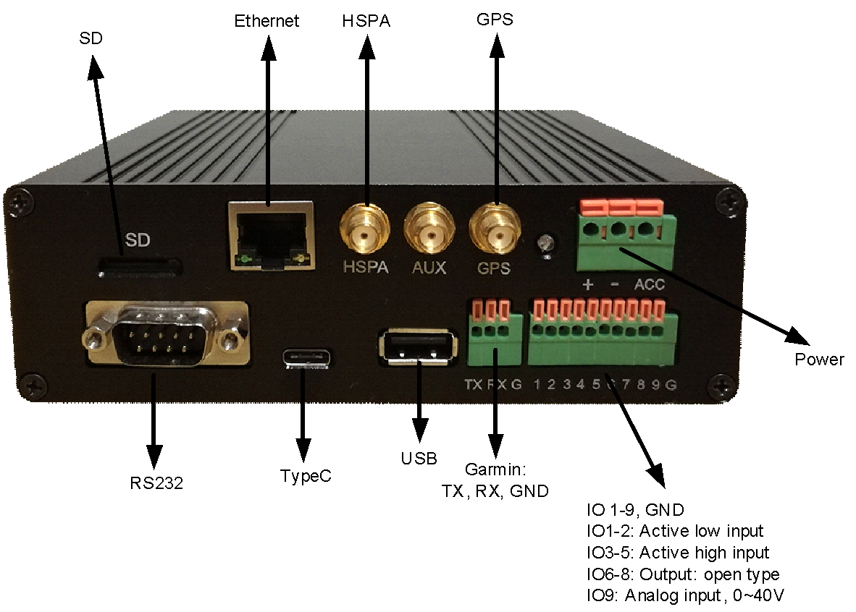

It meets industrial standards but also provides most flexibility and integration for extended business. It is a combination of MIFI router, GPS Tracker, controls , smartphone hardware extender and for third party integration.

Hardware

Smart Power | 7~40v  Control module power and boot sequences  - ACC control  - 5v microusb power supply | Support cars and trucks power  smart control and management
Wireless  Network | GSM | GPRS | EDGE: 850, 900, 1800, 1900  WCDMA/HSDPA/HSUPA/HSPA+: 800/850*, 900, AWS 1700, 1900, 2100 MHz, all bands with diversity | High speed internet connection  Removable Mini-PCIe module. *Optional module for LTE.
GPS | Ublox | Accuracy rate 2m
eMMC | Power loss protection | 4G
Smart HUB | Independent MCU ,IO and HUB control
USB Type-C | Smartphone integration  Charging and Communicating
1 Garmin RS232 | RS232 for Garmin data wires
1 RS232 | DB9 connector
2 USB-A
9 I/O | 2 active low, 3 active high, 3 open output,  1 analog
1 Ethernet port
1 SD card
accelerometer | 3-axis
Buzzer
Wifi | Wifi AP or client
OBD | OBD2/J1939/Elm327
Temperature | -40 ~85℃

Features

Mifi Router | Seamless high speed internet connection, port forwarding | Provide internet connection to third party device, tablets and computers
GPS tracker | Active antenna, Accuracy rate 2m | Dual Gps supported  Guaranteed delivery
eMMC | Power loss protection storage | 4G
Smart Power | Optional ACC control | Control boot power sequence  Control power on/off on modules.
Garmin dispatching | Rich feature on Garmin dispatching | Messaging, navigation, speed alert, stops, stop estimate and Gps assistant
OBD/J1939/Elm327 | Support most of trucks and cars | Mechanical alerts ,fuel, driver behavior alerts
IO controls | Support panic, PTO | Convenient connectors
Alerts | Panic, PTO, Speed, Engine, Fuel, Driver behavior, Impact/motion, Idle
COM integration | Configurable transparent communication, serial to tcp | Integrate third party controller devices
Geo fences | Unlimited
Udp/Tcp/Http | Support ACK and secure communication | Big offline cache available.  Extended protocols of previous version
Third-party integration | You may develop your plugin to make it your own product | Easy to integrate
Dynamic configuration | Hardware Interface might bind by configuration or by smart plug and play detection.
Rule Engine | Automation | Powerful for flexible business requirement.
WIFI router  Router or Client ready | Optional WIFI client or AP router | Switch by command or rule
Smartphone hardware extender | Smartphone as hardware hoster via USB type-C | Internal switch
Smartphone Integration | Charging and communicating

AI-linker V3 Use Cases ( might be limited on Compact version)

- GPS Tracker
7x24, Accurate GPS,Smooth trace, high speed internet connection, Integrated Garmin dispatching, OBD/J1939 dispatching, various alerts, geo fences, IO, Serial communications.

- Mobile router
Wifi AP or client with port control, 1 Ethernet port, high speed internet connection. Connect your third party device to Internet.

- Mobile sensor alerts
Powerful Rule engine with Javascript rule broaden your imagination. Rules might be triggered by IO, geo fence, alerts, signal strength and motion.

- Smartphone hardware extender
Use your smartphone to control all the hardware.

- Third party integration
Easy integration or even program your own plugin to make it your own product.
Modularized with removable Compute board, GPS board, Mini-PCIe network board and Smart power board.

